Fannie And Freddie: Fast Forward To April 15
About:FNMA Includes:FMCC

Summary
Two prior Fortune 50 companies Fannie Mae and Freddie Mac give all their money to the United States government, now totaling over $108B in less than 8 years.
A lawsuit dismissed late in 2014 is up for appeals in the DC District court in 2016 that could potentially turn over the earlier memorandum opinion.
If Fannie and Freddie are allowed to retain capital, equity shares currently trading as penny stocks may no longer be penny stocks.
Fannie Mae (OTCQB:FNMA) and Freddie Mac (OTCQB:FMCC) are often referred to as Government Sponsored Enterprises (GSEs) since they were brought into existence by the government and then sold to private investors decades ago. With no exception, since the time they have been brought into operational existence they have served as the gold standard and set the bar for the thirty year American home mortgage. Straight from Judge Lamberth's dismissal, the two GSEs are considered government-sponsored, rather than government-owned:
(click to enlarge)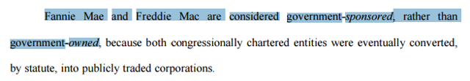
Before I dive into my reasoning on a point by point basis regarding why I agree with Judge Steele's assessment that "Perry Capital court's reasoning is utterly bankrupt," let's first discuss why you may be interested in learning more as an investor with money to allocate.
The Investment Opportunity In Brief
Right now, the equity securities of Fannie Mae and Freddie Mac on a valuation basis appear to trade like call options of their intrinsic value in a scenario where the two underlying operating entities are allowed to keep some of the money that they make. This is in contrast to their current arrangement whereby they make billions of dollars per year and that money is transferred quarterly to the US Government in an agreement between the government and itself designed to leave the GSEs penniless in 2018. In the process known as conservatorship, the two GSEs entered with their highest capital levels in history and have transferred $108B+ to the government while the government puts out news headlines suggesting that the GSEs are a broken business model. As an investor, $108B+ of cash across no more than 8 years is the opposite of a broken business model. I submit to you the hypothesis that Treasury knew exactly what it was doing the entire way through and this hypothesis has been corroborated by one of the GSEs prior CFO's Timothy Howard who points to internal Treasury discussions about the potential costs and benefits of nationalization:
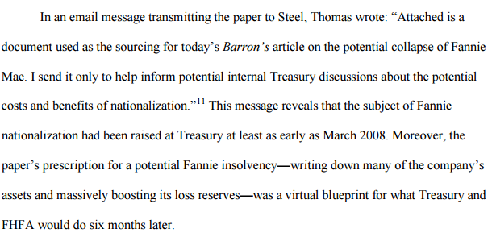
Secondly, another prior GSE executive and prior CFO Susan McFarland has provided testimony that we can't see but we can feel its gravitational pull on plaintiff's arguments to compel production of certain documents:
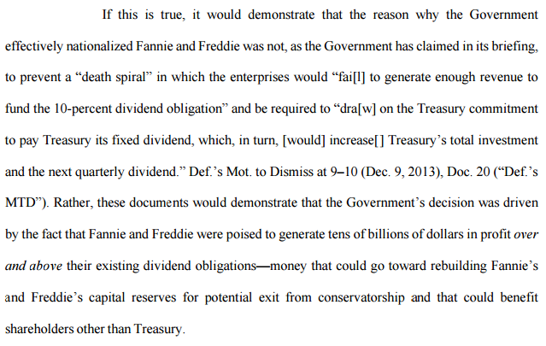
These two chief financial officers of Fannie Mae seem to be supporting the notion that the reason Fannie Mae is having financial problems is not because they aren't making any money as the government would have us believe but instead because the government is preventing them from keeping any of the money they make for themselves because the government wants to take all of their money as a matter of public policy. If Fannie Mae and Freddie Mac are at any point in time allowed to retain their earnings, equity shares of the two delisted penny stocks could trade significantly higher. William Ackman and Richard X. Bove seem to suggest that $20 is a good starting point on the common shares if the government decides to exercise the warrants that it took as part of the original agreement. Ackman projects a combine normalized earnings of $15B available to common shareholders if the government is no longer allowed to keep taking their money.
Now that you understand that the potential upside of owning securities is over 100%, let's review what's going on in the DC District's Court of Appeals.
Lamberth: The Difference Between Can't and Won't
Regardless, the MEMORANDUM OPINION issued by Lamberth proposes that HERA empowers FHFA to take everything without judicial review:
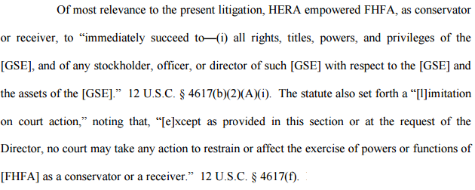
To Operate Outside The Statute Is To Violate The Statute
How exactly does the government unilaterally bankrupt two Fortune 50 companies by funneling their net worth to itself while acting as conservator when the powers as conservator are completely the opposite?
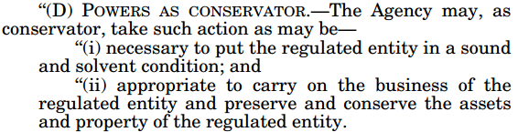
David Fiderer, who has written a book breaking down publicly available information on the GSEs proposes that the government has rationalized away the plain meaning of HERA and basic concepts of corporate law and insolvency law by saying that they are exempt from judicial review and has been able to stonewall shareholders at every turn by asserting evidentiary privileges. That's really where things get interesting for shareholders because in aggregate the legal teams that represent us have subsequently obtained evidence "which shows the government's defense to be outright false" that has been presented to the D.C. Circuit Court. In other words, while the government has been stonewalling in court A, the lawyers representing shareholders in court B were able to get evidence they say undermines the government's defense in court A and then submit this evidence to court A where the government put forth this defense that is now under Appeals.
The Net Worth Sweep Looks Like A New Security Per IRS Rules
Per the Perry Capital Institutional Appeal Brief, we quickly can discern that the nature of the Third Amendment Net Worth Sweep constitutes a new security by Treasury's own definition:
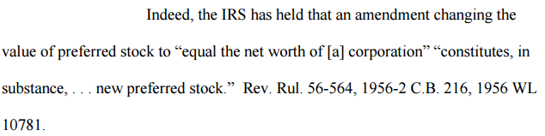
This is important because Treasury lacked the authority to purchase new securities after 2009. If the modification of a preferred security from a 10% dividend to taking the net worth of a company is by Treasury's own definition an entirely separate security altogether, plaintiffs suggest that this conduct is ultra vires. This would suggest that in this instance Treasury is willing to overlook its own rules for classifying transactions for tax purposes if by doing so it increases payments to Treasury. What's interesting is that most tax law is built around ensuring that taxes are paid when owed. This is instead a situation where a tax collector may have decided that it was owed more than should have ever been paid and where tax law can be used to protect taxpayers from tax collector over reach. From Lamberth's MEMORANDUM OPINION we see FHFA's claims:
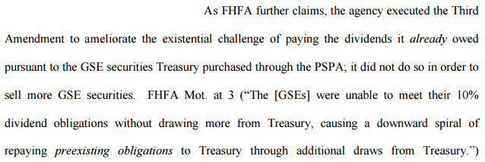
First off, dividends are not owed. There's a huge difference between equity dividends and debt interest. Secondly, there was a PIK clause that provided that the dividends could be paid in kind, suggesting that this alleged downward spiral of having to pay anything may simply be a story manufactured for the convenience of nationalizing two Fortune 50 companies without having to worry about shareholders. Lamberth basically didn't have the evidence on hand when he ruled that the court has now:
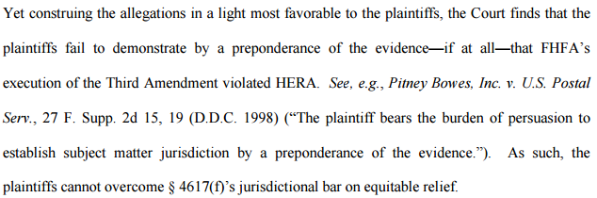
Now, with discovery being shared from Judge Sweeney's court, statements like that no longer can be made in so far as being made because they don't have evidence. Still in dispute, however, are 11,292 documents that the government has asserted various privileges over. My view on that is that Fairholme says that evidence has been submitted in the court proving the government's claims as false and from what I can see of the redacted legal filings from Fairholme, they've got a lot already. Even still, 11,292 documents is a lot of documents that the government doesn't want us to see. To put that in perspective if 100 people were emailing back and forth once a day for 90 days, you're still short of how many documents the government doesn't want us to see. To put it another way, it sure looks like the government isn't attempting to cover up any one particular thing as much as they seem to base their defense on covering up everything and the chief problem now is that depositions undermine their arguments and plaintiffs already are distributing discovery to courts far and wide.
Ugoletti's Written Affidavit Helped Lamberth Dismiss Earlier Lawsuit Now Being Appealed
As a reminder, Mario Ugoletti put out the statement used by Lamberth to help dismiss this case the first time:
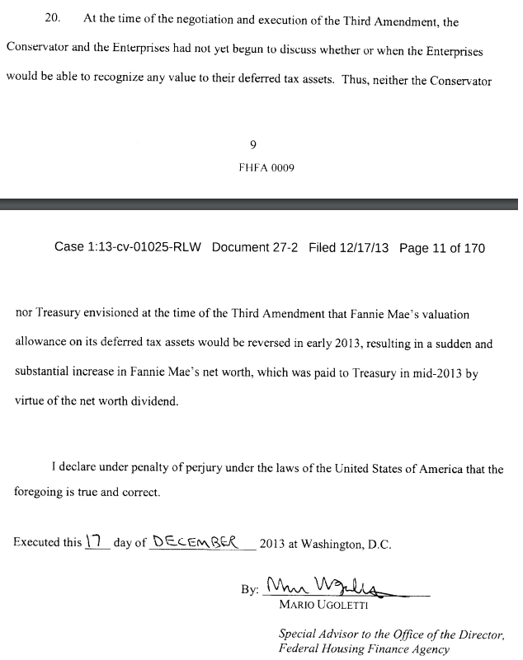
In a separate lawsuit, Saxton plaintiffs have brought into question Ugoletti's declaration above.
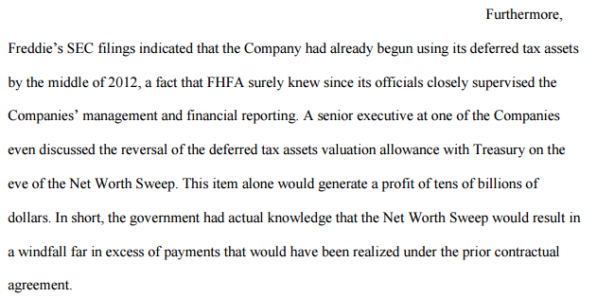
Either discussions happened or they did not. Ugoletti's written statement above says they did not. He was deposed, however, and according to plaintiffs his testimony calls into question evidence submitted by FHFA in the district court.
(click to enlarge)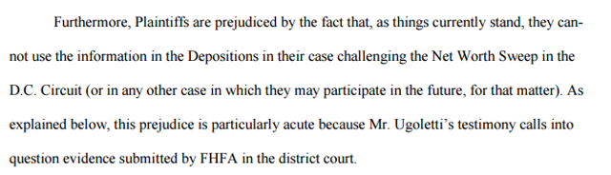
Then there's this as it relates to Ugoletti's testimony which seems to suggest that Ugoletti said something during his testimony that the government doesn't want us to see:
(click to enlarge)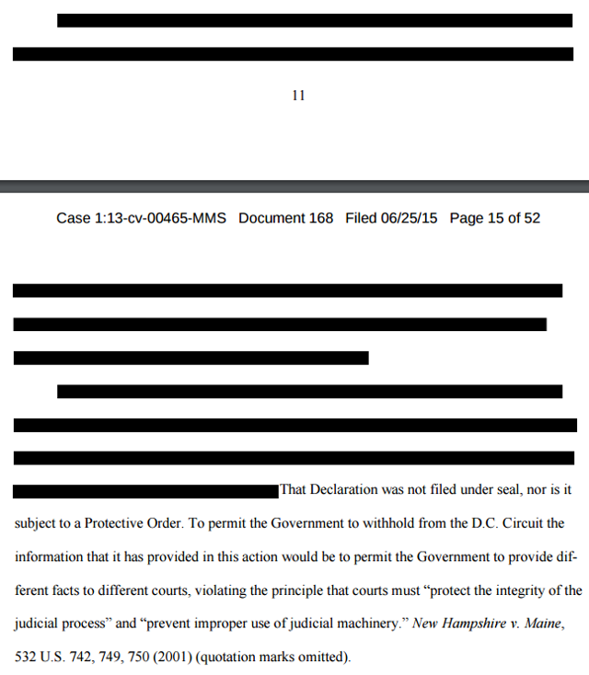
Here's what we know. We know that the government has told us that the Third Amendment Net Worth sweep was put in place to save Fannie and Freddie from a death spiral. It can only stand to reason that they don't want us to see what he said if it doesn't support their published perspective that it was enacted to protect taxpayers.
Summary & Conclusion
When Lamberth's ruling came out the stocks of Fannie Mae and Freddie Mac got obliterated. Since the time of his ruling, discovery in Judge Sweeney's court of claims has produced evidence that has subsequently been filed in the DC District Court of appeals.
This evidence at the very least does not seem to support the notion that the reason behind the Third Amendment Net Worth Sweep was to save Fannie and Freddie from a death spiral. My view is pretty simple and is basically that based on the new evidence submitted to the Appeals Court, plaintiffs will prevail and the equity shares could trade significantly higher. Oral arguments are on April 15 and the world is watching.

